- We expect April’s fall in UK GDP to mark the start of a soft patch. The seasonal pattern in the GDP data will exacerbate the drag on activity from the Middle East conflict, leaving the economy flirting with recession.
- Concerns about growth and the state of the labour market mean most members of the Monetary Policy Committee see the risks around the medium-term inflation outlook as two-sided. Given there’s not been a renewed spike in energy prices and that leading indicators of second-round effects remain benign, we’re confident the MPC will hold Bank Rate at 3.75% at next week’s meeting, with the vote likely to be 7-2.
The GDP data for April was this week's only major release. We had expected a fall in GDP that month, on the basis that March saw unusually large spikes in output across a number of sectors that looked hard to justify, and April’s retail sales release had already shown significant weakness. In the event, momentum cooled across the services sector, more than offsetting a fractional increase in construction output, while manufacturing production was unchanged. This meant that GDP fell 0.1% m/m in April.
Although April’s outturn could’ve been worse, and the detail suggests a chunk of the weakness was indeed payback for previous strength, we remain gloomy about the outlook for activity over the rest of this year. There’s scope for further payback in sectors such as accommodation and food, transport, and communications. And our downbeat view is also linked to the likely existence of some moving or residual seasonality in the GDP data. In the years since the pandemic, the strength seen in Q1 has begun to unwind from the spring. So far, this year’s data is telling a similar story (Chart 1). This suggests we may only be at the start of a period of weaker momentum.
Chart 1: The season pattern in the GDP data points to weaker momentum over the coming months
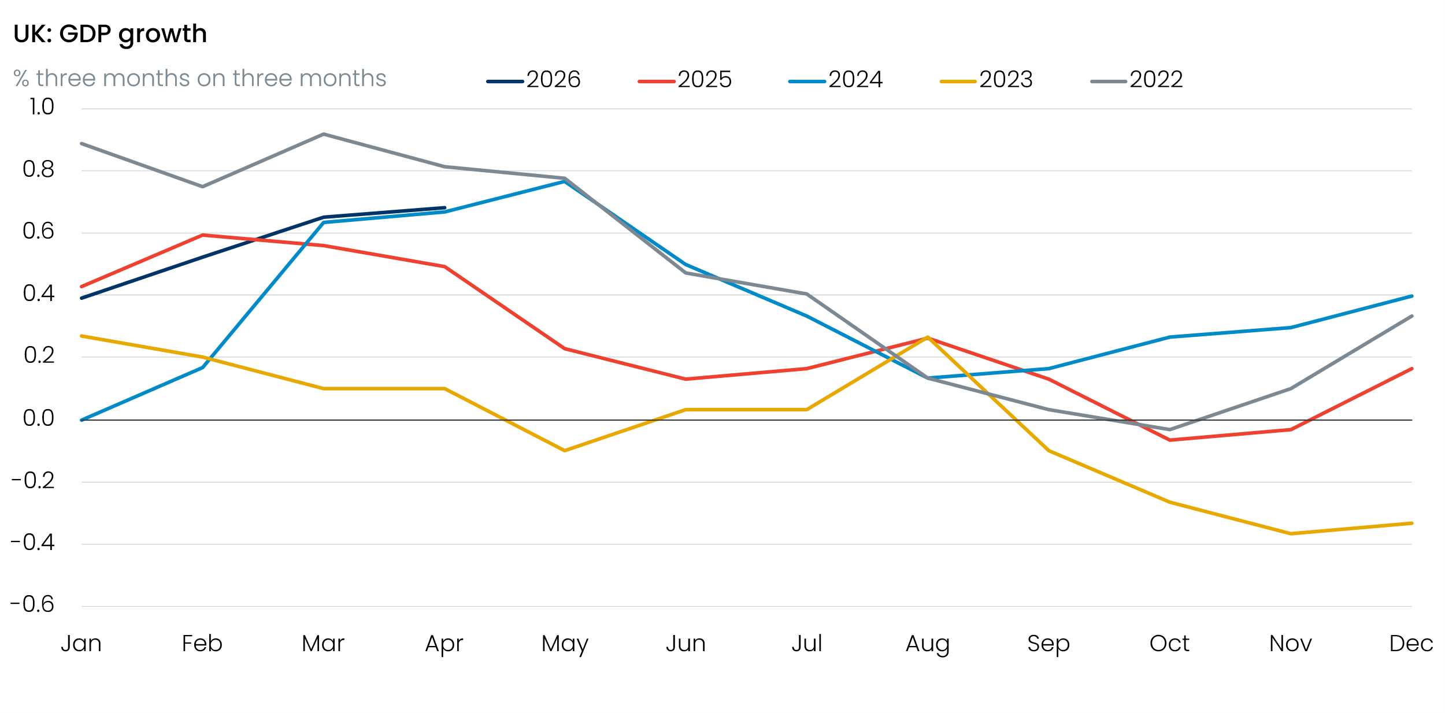
Source: Haver Analytics

Furthermore, the drag from moving or residual seasonality is set to coincide with the peak impact of the Middle East conflict. As we argued in a Research Briefing published last month, rising price pressures mean we expect real household incomes to flatline this year, which will weigh heavily on consumer spending growth. Meanwhile, a combination of rising input costs for firms, prompting greater margin pressures, and fragile corporate sentiment means business investment will underperform. As a result, we expect the economy will flirt with recession this year.
Although we doubt it will have a material impact on the outcome of next week’s Monetary Policy Committee meeting, this week’s GDP data may bolster some of the concerns raised by committee members. The majority of the MPC have cited evidence of weakness in activity and the labour market as reasons to think the risks to the medium-term inflation outlook are two-sided, rather than asymmetrically tilted to the upside.
Other news since the MPC’s April meeting is unlikely to have pushed the committee in a much more hawkish direction. Although shipping through the Strait of Hormuz remains severely disrupted, oil and gas futures prices remain close to the middle and lower scenarios set out in the Bank of England’s April Monetary Policy Report.
Elsewhere, what limited hard economic data has been published over the past six weeks has been relatively inconclusive. Meanwhile, the early warning signals for indirect and second-round effects that could push up medium-term inflation remain relatively benign. Both the Citi/YouGov survey of household inflation expectations and the BoE’s Decision Maker Panel show that although year-ahead inflation expectations are elevated, longer-term expectations remain at similar levels to those seen before the Middle East conflict, when cuts to Bank Rate were anticipated (Chart 2). These results are consistent with the idea that the energy shock will prove transitory, with only limited upward pressure on inflation at the policy-relevant horizon.
Chart 2: Near-term inflation expectations have risen, but the medium-term picture is little changed
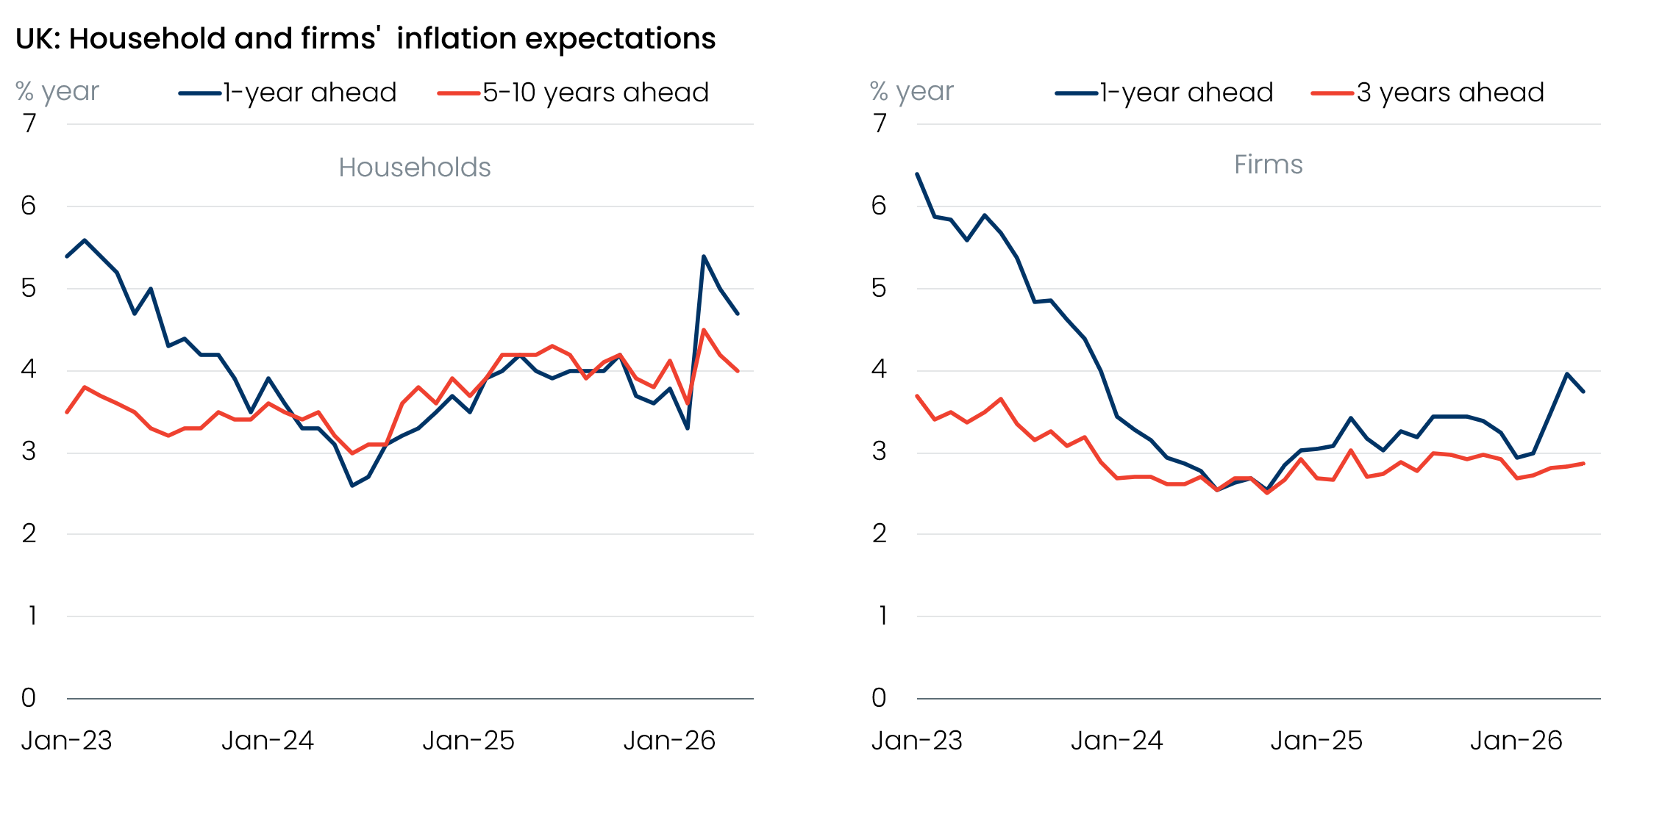
Sources: Citi/YouGov survey of inflation expectations, Bank of England Decision Maker Panel
Given recent comments from most committee members suggest they’re still some way off voting to tighten policy, and the absence of hawkish signals in the data published since the April meeting, we expect the MPC to hold Bank Rate at 3.75% in June. We think the vote split is likely to be slightly closer than at April’s meeting, with Megan Greene set to join arch-hawk Huw Pill in preferring a 25bp hike due to shared concerns that second-round effects could prove larger than the majority expect.

The week ahead
A hectic week begins with Wednesday’s inflation release. CPI inflation cooled in April, but given some of the downward pressure came from temporary factors, we think inflation rebounded in May. The pickup is likely to have been concentrated in the services category, with air fares set to recover after April’s outturn was weighed down by the timing of the Easter holidays. Services inflation will also be boosted by a base effect in the vehicle excise duty sub-category – the Office for National Statistics corrected an error in April’s data last year, which caused a large one-off month-on-month drop in the May 2025 release. But movements in the other major inflation categories are likely to be modest. So overall, we think CPI inflation rose to 3% in May, from 2.8% in April.
The ONS will publish its latest labour market release on Thursday. Last month’s release offered further evidence that regular pay growth continues to lose momentum. We think this trend is likely to have continued in April’s data. The slowdown for total pay growth will be exacerbated by January’s large increase in bonus payments falling out of the headline (three-month average of the annual rate) reading. Therefore, we forecast headline total pay growth of 3.9% and regular pay growth of 3.3% for the three months to April.
On the quantities side, the unemployment rate has fluctuated around the 5% mark since Q3 2025. With January’s low single-month outturn falling out of the three-month moving average, we think there’s a good chance that the unemployment rate edged up to 5.1% in the three months to April.
At noon on Thursday, the Bank of England’s Monetary Policy Committee will announce its June interest rate decision. Although energy prices remain elevated, most MPC members don’t appear close to voting for tighter policy yet. In part, this is because early warning signs of indirect and second-round effects remain relatively benign. Meanwhile, the lack of momentum in economic activity means these members continue to think the risks around the medium-term inflation outlook are two-sided. Therefore, we expect a 7-2 vote in favour of holding Bank Rate at 3.75%, with Megan Greene likely to join Huw Pill in voting for a 25bp rate rise due to shared concerns that the rest of the MPC is underestimating the scale of second-round effects.
Next week will close with the release of retail sales data for May. Sales volumes fell very sharply in April, driven by weaker food and non-store spending, alongside a particularly large decline in automotive fuel sales. But we think April’s falls in non-store and fuel spending look like a partial overcorrection. As a result, we think some payback in these categories will have supported a 0.2% month-on-month rise in retail sales volumes in May.

Table 1: Week ahead calendar
Date | Events | Period | Measure | Unit | Previous | Forecast
Jun 17 | CPI inflation | May | m/m | % | 0.7 | 0.4
Jun 17 | CPI inflation | May | y/y | % | 2.8 | 3.0
Jun 17 | RPI inflation | May | m/m | % | 0.7 | 0.5
Jun 17 | RPI inflation | May | y/y | % | 3.0 | 3.3
Jun 17 | Producer input prices | May | m/m | % | 2.3 | 0.5
Jun 17 | Producer input prices | May | y/y | % | 7.7 | 8.8
Jun 17 | Producer output prices | May | m/m | % | 1.4 | 0.4
Jun 17 | Producer output prices | May | y/y | % | 4.1 | 3.8
Jun 18 | LFS unemployment | Feb-Apr | Rate | % | 5.0 | 5.1
Jun 18 | Average earnings (total pay) | Apr | 3m, y/y | % | 4.1 | 3.9
Jun 18 | Average earnings (regular pay) | Apr | 3m, y/y | % | 3.4 | 3.3
Jun 18 | BoE Bank Rate decision | Jun | Bank Rate | % | 3.75 | 3.75
Jun 19 | Public finances | May | PSNB | £bn | 24.3 | 18.1
Jun 19 | Retail sales inc fuel | May | m/m | % | -1.3 | 0.2
Jun 19 | Retail sales inc fuel | May | y/y | % | 0.0 | 1.6
Source: Oxford Economics

Key forecasts
Table 2: UK forecast overview
(ANNUAL PERCENTAGE CHANGES UNLESS SPECIFIED)
 | 2024 | 2025 | 2026 | 2027 | 2028 | 2029
GDP | 1.0 | 1.4 | 0.7 | 0.7 | 1.8 | 1.7
Private consumption | -0.1 | 0.8 | 0.6 | 0.4 | 1.5 | 1.8
Fixed investment | 1.7 | 4.3 | 0.3 | 1.5 | 2.5 | 2.1
Government consumption | 2.9 | 1.6 | 1.3 | 1.6 | 1.4 | 1.2
Consumer prices | 2.5 | 3.4 | 3.4 | 2.7 | 1.8 | 2.0
Unemployment rate (%) | 4.3 | 4.9 | 5.4 | 5.6 | 5.1 | 4.7
Current a/c balance (% of GDP) | -3.0 | -2.4 | -3.8 | -3.2 | -2.6 | -2.5
Government balance (% of GDP) | 5.2 | 5.0 | 3.8 | 3.7 | 3.0 | 2.7
Central bank policy rate (%, EOP) | 4.75 | 3.75 | 3.75 | 3.50 | 3.00 | 2.75
10yr govt. bond yield (%, EOP) | 4.57 | 4.47 | 5.03 | 4.49 | 3.84 | 3.56
Exchange rate (US$ per £, EOP) | 1.25 | 1.35 | 1.30 | 1.30 | 1.30 | 1.30
Exchange rate (euro per £, EOP) | 1.21 | 1.15 | 1.12 | 1.10 | 1.10 | 1.10
Source: Oxford Economics
Table 3: Quarterly forecasts for the UK
 | 2026 |  |  |  | 2027
 | Q1 | Q2 | Q3 | Q4 | Q1 | Q2 | Q3 | Q4
GDP (% year) | 1.1 | 0.9 | 0.6 | 0.4 | 0.2 | 0.5 | 1.0 | 1.3
CPI inflation (% year) | 3.1 | 3.0 | 3.7 | 4.0 | 3.8 | 3.0 | 2.2 | 1.9
Bank Rate (%, EOP) | 3.75 | 3.75 | 3.75 | 3.75 | 3.75 | 3.75 | 3.75 | 3.50
10yr gilt yield (%, EOP) | 4.88 | 5.00 | 5.04 | 5.03 | 4.98 | 4.85 | 4.68 | 4.49
US$ per £ (EOP) | 1.32 | 1.34 | 1.32 | 1.30 | 1.30 | 1.30 | 1.30 | 1.30
Euro per £ (EOP) | 1.14 | 1.16 | 1.14 | 1.12 | 1.11 | 1.10 | 1.10 | 1.10
Source: Oxford Economics

Latest Country Economic Forecast:
May 21, 2026

Recent publications

Data Insights
Strong start to the year begins to fade
PMI signals a late spring slowdown
Mortgage approvals marched higher in April, despite costlier deals
Manufacturing strength won’t last
Public finances softer than expected

Research Briefings
MPC preview – Another hold, but the door will be kept open to hikes
Is a more optimistic view on recent productivity trends justified?
Debt predicament – structural weakness and a credibility deficit
Are European countries with high AI use seeing higher productivity growth?
Weak real incomes set to subdue consumer spending

Contacts

Oxford Economics' UK team
- Andrew Goodwin – Chief UK Economist – agoodwin@oxfordeconomics.com
- Edward Allenby - Senior UK Economist - eallenby@oxfordeconomics.com

